**Chapter 5**

**Multiple Integration**

**5.3 Double Integrals in Polar Coordinates**

**Section Exercises**

**In the following exercises, express the region  in polar coordinates.**

122.  is the region of the disk of radius  centered at the origin that lies in the first quadrant.

Answer: 

123.  is the region between the circles of radius  and radius  centered at the origin that lies in the second quadrant.

Answer: 

124.  is the region bounded by the **-axis and 

Answer: 

125.  is the region bounded by the -axis and 

Answer: 

126. 

Answer: 

127. 

Answer: 

**In the following exercises, the graph of the polar rectangular region  is given. Express ** in polar coordinates.**

128.

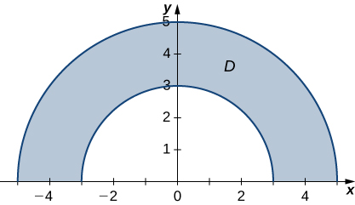

Answer: 

129.

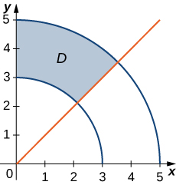

Answer: 

130.

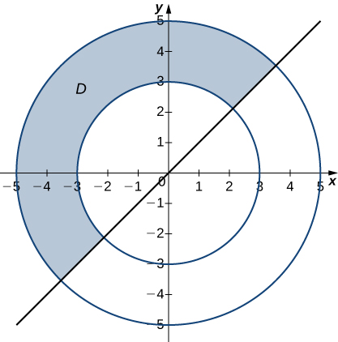

Answer: 

131.

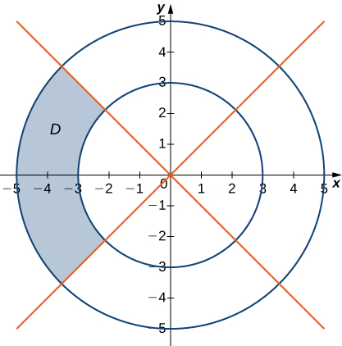

Answer: 

132. In the following graph, the region  is situated below  and is bounded by  and 

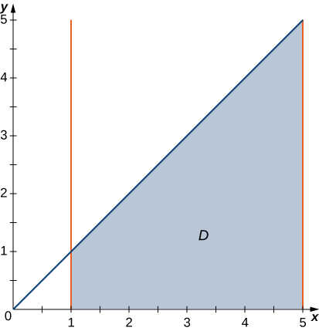

Answer: 

133. In the following graph, the region  is bounded by  and 

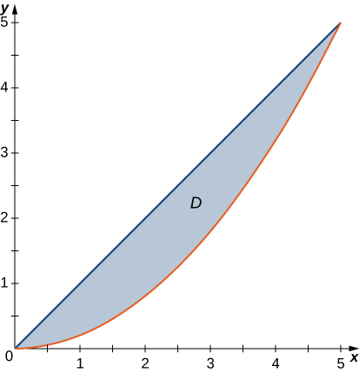

Answer: 

**In the following exercises, evaluate the double integral  over the polar rectangular region **

134. 

Answer: 

135. 

Answer: 

136. 

Answer: 

137. 

Answer: 

138.  where 

Answer: 

139.  where 

Answer: 

140.  where 

Answer: 

141.  where 

Answer: 

142. 

Answer: 

143. 

Answer: 

**In the following exercises, the integrals have been converted to polar coordinates. Verify that the identities are true and choose the easiest way to evaluate the integrals, in rectangular or polar coordinates.**

144. 

Answer: 

145. 

Answer: 

146. 

Answer: 

147. 

Answer: 

**In the following exercises, convert the integrals to polar coordinates and evaluate them.**

148. 

Answer: 

149. 

Answer: 

150. 

Answer: 

151. 

Answer: 

152. Evaluate the integral  where  is the region bounded by the polar axis and the upper half of the cardioid 

Answer: 

153. Find the area of the region  bounded by the polar axis and the upper half of the cardioid 

Answer: 

154. Evaluate the integral  where is the region bounded by the part of the four-leaved rose  situated in the first quadrant (see the following figure).

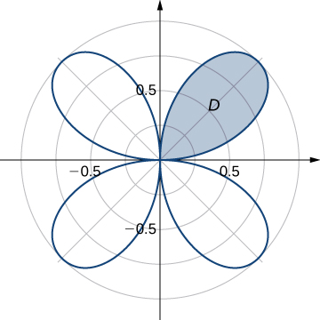

Answer: 

155. Find the total area of the region enclosed by the four-leaved rose  (see the figure in the previous exercise).

Answer: 

156. Find the area of the region  whichis the region bounded by    and 

Answer: 

157. Find the area of the region  whichis the region inside the disk  and to the right of the line 

Answer: 

158. Determine the average value of the function over the region  bounded by the polar curve  where  (see the following graph).

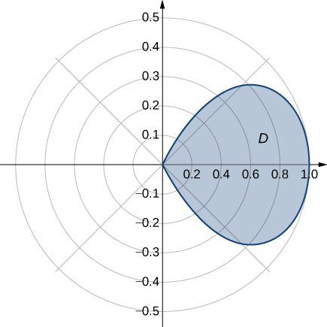

Answer: 

159. Determine the average value of the function  over the region  bounded by the polar curve  where  (see the following graph).

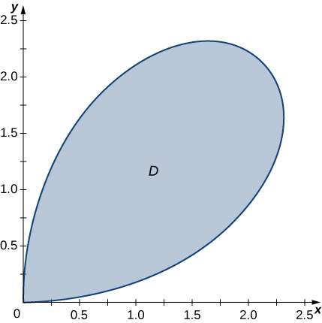

Answer: 

160. Find the volume of the solid situated in the first octant and bounded by the paraboloid  and the planes  and 

Answer: 

161. Find the volume of the solid bounded by the paraboloid  and the plane 

Answer: 

162. a. Find the volume of the solid  bounded by the cylinder  and the planes and 

b. Find the volume of the solid  outside the double cone  inside the cylinder  and above the plane 

c. Find the volume of the solid inside the cone  and below the plane  by subtracting the volumes of the solids  and 

Answer: a.  b.  c. 

163. a. Find the volume of the solid  inside the unit sphere  and above the plane 

b. Find the volume of the solid  inside the double cone  and above the plane 

c. Find the volume of the solid outside the double cone  and inside the sphere 

Answer: a.  b.  c. 

**For the following two exercises, consider a spherical ring, which is a sphere with a cylindrical hole cut so that the axis of the cylinder passes through the center of the sphere (see the following figure).**



164. If the sphere has radius and the cylinder has radius  find the volume of the spherical ring.

Answer: 

165. A cylindrical hole of diameter  cm is bored through a sphere of radius  cm such that the axis of the cylinder passes through the center of the sphere. Find the volume of the resulting spherical ring.

Answer:  

166. Find the volume of the solid that lies under the double cone  inside the cylinder  and above the plane 

Answer: 

167. Find the volume of the solid that lies under the paraboloid  inside the cylinder  and above the plane 

Answer: 

168. Find the volume of the solid that lies under the plane  and above the disk 

Answer: 

169. Find the volume of the solid that lies under the plane  and above the unit disk 

Answer: 

170. A radial function  is a function whose value at each point depends only on the distance between that point and the origin of the system of coordinates; that is,  where  Show that if  is a continuous radial function, then  where  and  with  and 

Answer: This is a proof; therefore, no answer is provided.

171. Use the information from the preceding exercise to calculate the integral  where  is the unit disk.

Answer: 

172. Let  be a continuous radial function defined on the annular region where  , and  is a differentiable function. Show that 

Answer: This is a proof; therefore, no answer is provided.

173. Apply the preceding exercise to calculate the integral  where  is the annular region between the circles of radii  and  situated in the third quadrant.

Answer: 

174. Let be a continuous function that can be expressed in polar coordinates as a function of  only; that is,  where  with  and  Show that  where  is an antiderivative of

Answer: This is a proof; therefore, no answer is provided.

175. Apply the preceding exercise to calculate the integral  where .

Answer: 

176. Let  be a continuous function that can be expressed in polar coordinates as a function of  only; that is,  where  with  and  Show that  where  and  are antiderivatives of  and respectively.

Answer: This is a proof; therefore, no answer is provided.

177. Evaluate  where 

Answer: 

178. A spherical cap is the region of a sphere that lies above or below a given plane.

1. Show that the volume of the spherical cap in the figure below is 

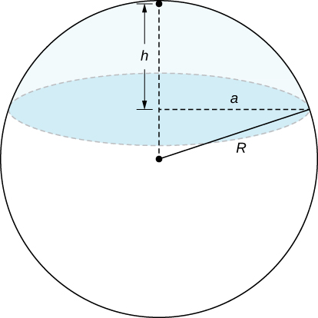

Answer: This is proof; therefore, no answer is provided

1. A spherical segment is the solid defined by intersecting a sphere with two parallel planes. If the distance between the planes is  show that the volume of the spherical segment in the figure below is 

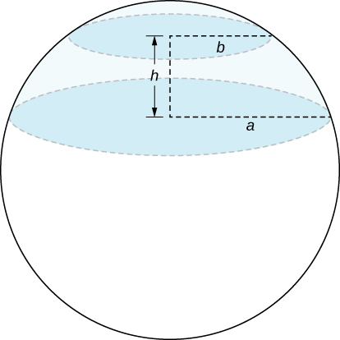

Answer: This is a proof; therefore, no answer is provided.

179. In statistics, the joint density for two independent, normally distributed events with a mean  and a standard distribution  is defined by  Consider  the Cartesian coordinates of a ball in the resting position after it was released from a position on the *z*-axis toward the -plane. Assume that the coordinates of the ball are independently normally distributed with a mean  and a standard deviation of  (in feet). The probability that the ball will stop no more than  feet from the origin is given by  where  is the disk of radius *a* centered at the origin. Show that 

Answer: This is a proof; therefore, no answer is provided.

180. The double improper integral  may be defined as the limit value of the double integrals  over disks  of radii *a* centered at the origin, as *a* increases without bound; that is, 

1. Use polar coordinates to show that 
2. Show that  by using the relation 

Answer: This is a proof; therefore, no answer is provided.

This file is copyright 2016, Rice University. All Rights Reserved.